Call for Paper
ICKITS’26 has been widely deployed to discuss Innovations and Technologies to achieve Sustainable Development Goals by United Nations. Contributions are invited across all the disciplines of Engineering toward the Sustainable Society, Sustainable Technology & Education, Sustainable economy, Sustainable health care, sustainable cities and Sustainable living, but not limited.

1.Foundation and Frontiers of Artificial Intelligence for Sustainable Futures
Trustworthy and explainable AI for real-world decision systems
Generative AI for sustainable design, planning, and innovation
Human-AI collaboration and intelligent user experience design
Ethical, legal, and governance frameworks for responsible AI
AI adoption strategies for resilient and sustainable organizations

2. Next-Generation Machine Learning and Deep Learning Systems
Sustainable and energy-efficient machine learning architectures
Federated, edge, and privacy-preserving learning systems
Fairness, accountability, and bias mitigation in ML models
Reinforcement and self-supervised learning for dynamic environments
Hybrid deep learning models for complex intelligent applications

3.Smart Agriculture, Food Systems, and Rural Innovation Technologies
Precision agriculture using AI, IoT, and data-driven decision systems
Satellite, drone, and sensor-based crop monitoring and yield analytics
Climate-smart farming technologies for resilient food production
Blockchain-enabled agricultural traceability and food transparency
AgriTech policy, rural innovation ecosystems, and sustainable livelihoods

4.Digital Twins and Intelligent Simulation for Sustainability
Digital twins for smart manufacturing and infrastructure systems
Urban digital twins for planning and sustainability assessment
Twin-driven optimization in healthcare, agriculture, and energy
Simulation-based forecasting for complex socio-technical systems
Data fusion and real-time synchronization for digital twin ecosystems

5.Responsible Innovation, Policy, and Technology Foresight
Governance of emerging technologies in uncertain futures
Responsible research and innovation for sustainable development
Scenario planning and technology foresight for policymakers
Standards, regulations, and compliance in digital transformation
Cross-sector policy frameworks for sustainable technological growth

6. Data Science, Decision Intelligence, and Sustainable Analytics
Big data platforms for sustainability intelligence
Decision support systems for complex policy and management problems
Visual analytics for climate, health, and urban systems
Responsible data ecosystems and open knowledge platforms
Predictive analytics for sustainable organizational transformation

7. Circular Economy, Smart Materials, and Sustainable Industrial Innovation
Intelligent systems for waste reduction, recycling, and resource recovery
Circular manufacturing models enabled by digital technologies
Smart and sustainable materials for future engineering applications
Lifecycle assessment and eco-design for industrial systems
Industrial symbiosis and data-driven sustainability optimization

8.Quantum Technologies, Advanced Devices, and Photonic Systems
Quantum computing frameworks for sustainable optimization problems
Silicon photonics and next-generation optical communication systems
Advanced semiconductor devices, memory, and logic architectures
2D materials, heterogeneous integration, and nanoelectronic fabrication
Scalable quantum hardware, packaging, and fault-tolerant systems

9.Cybersecurity, Digital Trust, and Privacy Engineering
AI-enabled cyber threat intelligence and autonomous defense systems
Cyber resilience in critical infrastructure and industrial ecosystems
Privacy-preserving analytics, anonymization, and differential privacy
Digital forensics, anomaly traceback, and attack attribution
Cyber policy, governance, and economics of data protection
10. Advancing Blockchain and Distributed Technologies
Blockchain scalability and consensus protocols
Energy-efficient blockchain alternatives (PoS, DAGs)
Interoperability between blockchain networks
Regulatory outlook for blockchain integration
Blockchain for supply chain traceability

Manuscript Submission Guidelines
We invite researchers, academicians, industry professionals, and practitioners to submit original, high-quality, and unpublished research papers presenting conceptual, innovative, experimental, or theoretical contributions in the conference themes and related areas. Submission of a manuscript implies that the work has not been previously published and is not under consideration for publication elsewhere.

General Guidelines
- Manuscripts should be prepared according to the conference template and must be limited to 6–8 pages, including figures, tables, and references.
- All submitted papers will undergo a double-blind peer-review process and will be evaluated based on originality, technical quality, relevance, significance, and clarity of presentation.
- The corresponding author is responsible for ensuring that all co-authors have reviewed and approved the submitted manuscript and consented to its publication.
- Authors are solely responsible for the content of their submissions, including obtaining necessary permissions for copyrighted material.
- The conference organizers and publisher shall not be held liable for any claims arising from the content of submitted papers.
- Authors will be notified of the review outcome (acceptance, revision, or rejection) via email.
- At least one author of each accepted paper must complete the conference registration and present the paper at the conference for inclusion in the conference proceedings.
Guidelines for Oral Presentation
Authors of accepted papers are required to present their work during the conference. Each presentation will be allotted 15 minutes, including time for questions and discussion. You can use any form of presentation you wish. Please arrive for your presentation early to ensure the necessary arrangements.
Speakers details
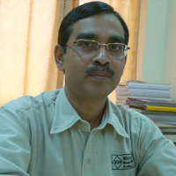
Dr.Debasis Samantha,Professor,
Department of Computer Science and Engineering,
Indian Institute of Technology Kharagpur, India.

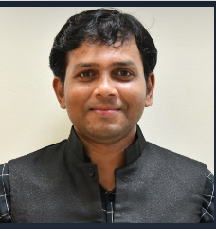

Dr. Damodar Reddy Edla
Associate Professor, Department of Computer Science and Engineering,
National Institute of Technology, Goa.
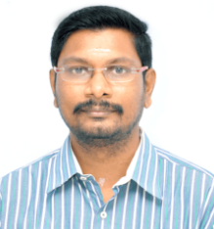
Dr.P.Arun raj Kumar , Assocaite Professor,
National Institute of Technology Calicut.
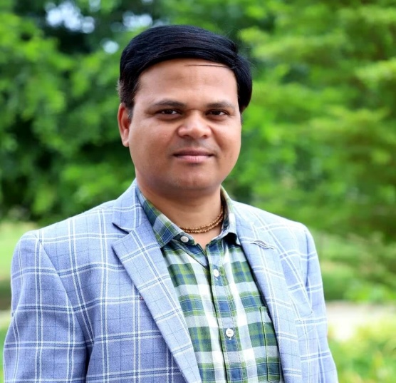
Dr.Sachi Nandan Mohanty, Singidunum University, Serbia, Mail id: snandan.mohanty@singidunum.ac.rs


Mr.Phaneendra Nath,
Machine Learning Engineer,
American Express,Sunnyvale,California,United states.

